Project Design Phase-II Technology Stack (Architecture & Stack)

|  |  |
| --- | --- |
| Date | 20 October 2022 |
| Team ID | PNT2022TMID592873 |
| Project Name | Project - Deep Learning Model for Detecting Diseases in Tea Leaves |
| Maximum Marks | 4 Marks |

Technical Architecture:

The Deliverable shall include the architectural diagram below and the information as per the table1 & table 2

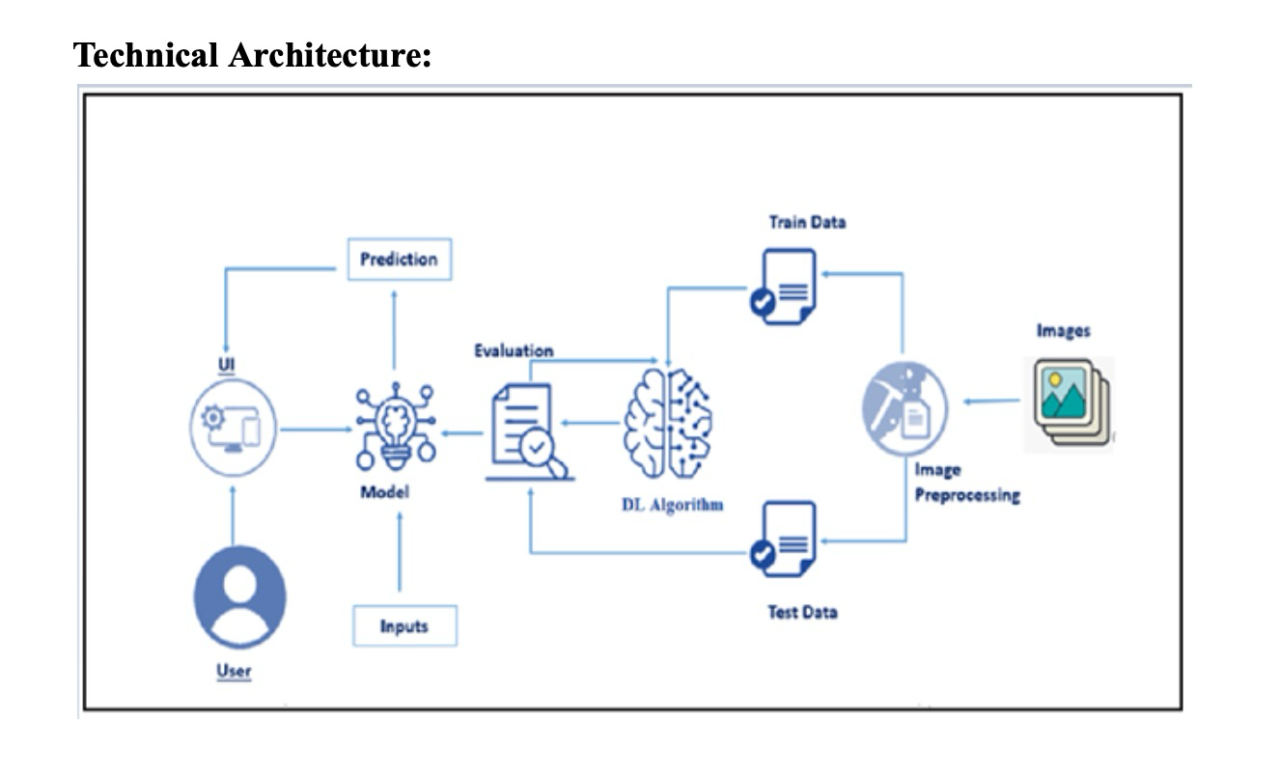

Table-1 : Components & Technologies:

|  |  |  |  |
| --- | --- | --- | --- |
| **S.No** | **Component** | **Description** | **Technology** |
| 1. | User Interface | How the user interacts with the application e.g. Web UI. | HTML, CSS, JavaScript / Flask, etc. |
| 2. | Application Logic-1 | Logic for a process in the application | Python |
| 5. | File Storage | File storage requirements | Personal computer or laptop |
| 6. | External API-1 | Purpose: Helps to work with multidimensional variables, matrices used for image processing | Tensorflow |
| 7. | External API-2 | Purpose: Framework which contains deep learning models used in transfer learning | Keras |
| 8. | Deep Learning Model | Purpose: To classify the diseases in the tea leaves using the VGG 16 DL model | VGG 16 DL model and dense ANN layers |
| 9. | Infrastructure (Server) | Application Deployment on Local System  Local Server Configuration: <http://127.0.0.1:5000/> | Local |

Table-2: Application Characteristics:

|  |  |  |  |
| --- | --- | --- | --- |
| **S.No** | **Characteristics** | **Description** | **Technology** |
| 1. | Open-Source Frameworks | List the open-source frameworks used | Tensorflow,keras |
| 2. | Security Implementations | List all the security / access controls implemented, use of firewalls etc. | Works on only local server |
| 3. | Availability | Justify the availability of application (e.g. use of load balancers, distributed servers etc.) | Flask server |
| 4. | Performance | Design consideration for the performance of the application | It will detect 79 percent of accuracy |

a